Thought starter: "Humanity’s 21st century challenge is to meet the needs of all, within the means of the planet." – Kate Raworth
What Is The Economy?
1. Label the diagram with the what you think each arrow might represent.
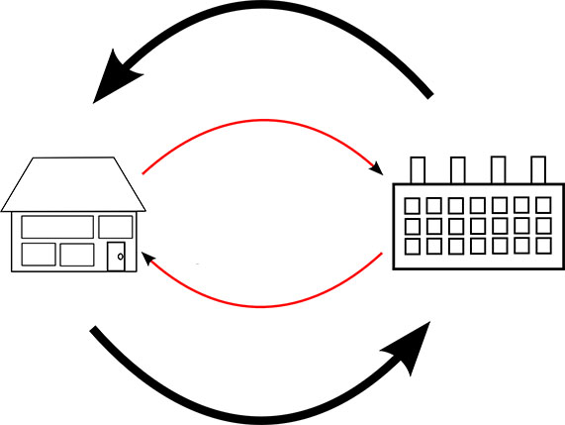

2. Think – Pair – Share
- Work independently to answers to the questions in Column A of the table below. Record your answers in Column B.
- Team up with a partner to share and discuss your ideas. Add any new thoughts to Column C.

Column A | Column B | Column C
- What problems do you see with such as simplistic economic model?
- Who and what is not being represented – what is missing?
3. In your pairs, list all the things that are not represented in this model in the space below or by annotating the diagram above.

What Is The Economy For?
1. Work in pairs or small groups to discuss each of the models you have looked at. Through your discussion try to critically evaluate the circular and doughnut models of the economy, highlighting the strengths and weaknesses of each and the impact they have on environmental and social wellbeing. For more information on Doughnut Economics visit doughnuteconomics.org
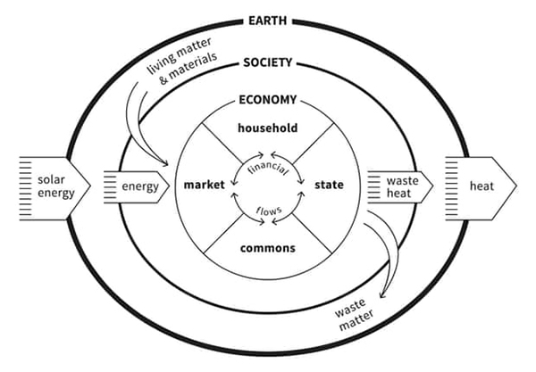
(Title: The Embedded Economy
Credit: Kate Raworth and Marcia Mihotich. CC-BY-SA 4.0
Citation: Raworth, K. (2017), Doughnut Economics: seven ways to think like a 21st century economist. London: Penguin Random House.)
Record your ideas below:

2. Work with a partner to brainstorm a list based on the following question:
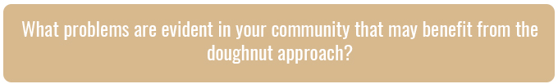
Record your thoughts here:

3. Now work independently or in pairs to select one problem and identify a solution that could work in your community.
For example, traffic congestion around schools is a major problem for some communities. Setting up a carpooling system or a walking school bus could help reduce the congestion but also build up community relationships, reduce car emissions and pollution, encourage all students to come to school, and help children be more active.
- A problem that could be solved in our community is…

- Solutions to this problem could be…

- Taking these actions takes the pressure off the outer rim (planetary boundaries) by…

- Taking these actions helps people move out of the centre hole (social factors of wellbeing) by…

Reflection
Work independently to think reflect on your understanding of economic frameworks and respond to the following:
- I used to think...

- Now I think...

