Doughnut Economics Case Studies Years 9 & 10 Student Worksheet
Name: …………………………………. Class: …………..

Thought starter: “We need to create an economy that meets the needs of all people within the means of the living planet.” – Kate Raworth.

What is Doughnut Economics?
Review the features of ‘The Doughnut’ using this diagram.
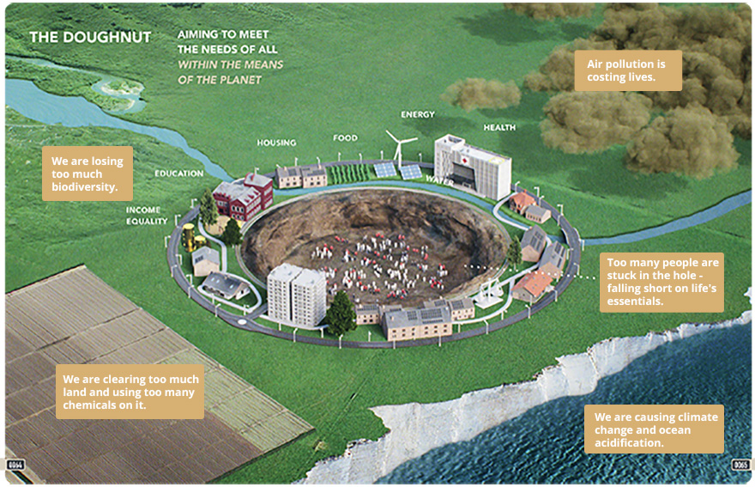

Doughnut Case Study – Decentralised Electricity Grid
You will now watch a clip from the 2040 documentary film that provides a case study of a decentralised electricity grid in India as an example of an innovation that brings people into the Doughnut. Use the following questions to reflect on this clip:
What’s Your 2040 – For Energy?
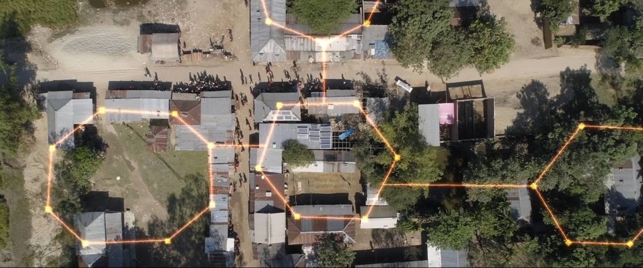
Password: 2040_EDU
(https://vimeo.com/showcase/6167669/video/336504721)
- How did this clip make you feel and why?

- What was most interesting or inspiring about this clip?

- What were the main messages of the clip and how relevant are they to you?

- What questions do you still have about this clip?

Read this diagram to explore how microgrids help bring people into the Doughnut:
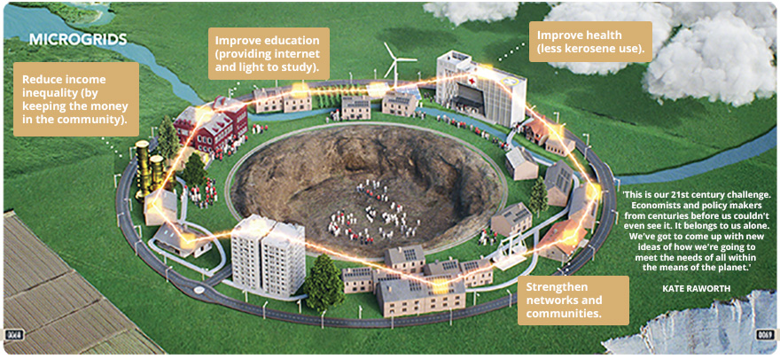

Exploring Economic Solutions
You will now be investigating, in groups, a 2040 solution like that of the decentralised electricity grid in India. Your ‘expert’ group will be assigned one of the following 2040 solutions to study and rate. You will then take your learning back to your ‘home’ group for sharing.
- 2040 – Seaweed as Food (https://vimeo.com/showcase/6167669/video/304290496)
- 2040 – Aero farm (https://vimeo.com/showcase/6167669/video/336498074)
- 2040 – Transport Case Study (https://vimeo.com/showcase/6167669/video/336509114)
- Empowering women and girls (https://vimeo.com/showcase/6167669/video/336513493)
Note: Password for all clips is: 2040_EDU
2040 Solution Clip Name:
Describe the problem:
- What pressures are being placed on the planet (outer ring)?

- What shortfalls are people facing (inside the hole)?

Describe the solution:
- How does this solution help reduce pressure on the planet?

- How does this solution help bring people out of the hole and into the doughnut?

Reflection
Work independently to complete the following reflection questions:
Identify and justify which solution you felt …
- … has the biggest impact on the wellbeing of people

- … has the biggest impact on the wellbeing of the planet

- … is the most realistic and achievable

