Exploring The Themes Of 2040 Years 7–10 Teacher Worksheet

Teacher preparation
Learning intentions: Students will…
- …understand some of the key concepts and messages of the 2040 documentary film.
- …understand how a documentary film can engage, inform and inspire.
- …understand that solutions to global environmental and social challenges already exist.
Success criteria: Students can…
- …work collaboratively.
- …undertake research online.
- …participate in group discussion.
- …participate in a group brainwriting activity.
- …watch and reflect on a documentary film.

Teacher content information: A recent study by The University of Melbourne on the thoughts and concerns of young people from Generations X and Y found the number one concern across both groups was lack of action around climate change. In particular, “Generation X worries what climate change will mean for their own children, while Generation Y is concerned about the impact on future generations” (source). The report indicates that young people have a serious mistrust in the Government’s ability or willingness to tackle climate change.
Tackling climate change requires large-scale, systemic changes across all aspects of society. Simply aiming to reduce our C0₂ emissions is not enough: we need to rapidly decarbonise our planet. While this might sound challenging, the good news is we already have the knowledge and tools to do it.
2040 is an innovative feature documentary that looks to the future, while focusing on what is happening now. Award-winning director Damon Gameau (director of That Sugar Film) embarks on a journey to explore what the future could look like by the year 2040 if we simply embraced the best solutions already available to us to improve our planet and shifted them into the mainstream.
The film will demonstrate to your students that we already have the solutions to climate change; we just need to take action to bring them rapidly into the mainstream. The 2040 documentary and curriculum package will support your students in turning this knowledge into positive action for a better future.
Find out how to see the film here. 2040 will only be available in cinemas for the first part of 2019 and you can make a group booking for your class at your local cinema during the film’s theatrical release which starts on May 23. These lessons have been designed with a media library to support teachers. The film will be available on video-on-demand and DVD later in 2019.
The film is the entry point to a global impact campaign that seeks to mobilise audiences to learn about, contribute to, advocate for and invest in regenerative solutions that improve the wellbeing of the planet, all people and all living systems. To join the Regeneration and share your vision for 2040, see the website.
Watch the 2040 trailer:
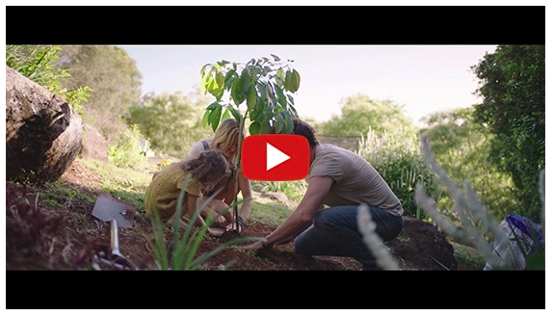
https://youtu.be/sR51ZDNSRFQ
Cool Australia, GoodThing Productions and Regen Pictures would like to acknowledge the generous contributions of Good Pitch Australia, Shark Island Institute, Documentary Australia Foundation, The Caledonia Foundation and our philanthropic partners in the development of these teaching resources.

Teaching sequence
Work through this resource material in the following sequence:
10 minutes – Part A: Activating Prior Knowledge
25 minutes – Part B: Exploring Challenges For The Future
20 minutes – Part C: Exploring Solutions For The Future
92 minutes– Part D: Watching The 2040 Documentary
5 minutes – Reflection

Part A: Activating Prior Knowledge
Step 1. Explain to students that in this lesson they will be exploring a documentary film called 2040. In this documentary, the filmmaker – Damon Gameau – looks at the big challenges facing our planet and investigates what solutions already exist to address these challenges. Students will be watching this film later in the lesson.
Before watching the film and investigating the content of the film it would be useful for students to have an understanding of some of the key terms used in the film.
Distribute a copy of the Student Worksheet to each student and explain that the sheet contains some of the key terms used and explored in the 2040 documentary. Invite each student to interview three people in their class about their understandings of the following words. The student being interviewed needs to provide a brief definition of each term while the interviewer needs to record these definitions on the Student Worksheet:
- Climate change
- Greenhouse gas
- Carbon dioxide
- Carbon sequestration
- Sustainability
Step 2. Once complete, invite students to share their definitions with the class, using the descriptions below to clarify student understanding:
- Climate change – Suggested definition: Climate change is a change in the pattern of weather, and related changes in oceans, land surfaces and ice sheets, occurring over time scales of decades or longer.
- Greenhouse gas – Suggested definition: A gas that contributes to the greenhouse effect.
- Carbon dioxide – Suggested definition: Carbon dioxide (CO₂) is generally a minor, yet very important, component of the atmosphere. CO₂ is released through natural processes like respiration and volcano eruptions, but also through human activities such as deforestation and burning fossil fuels. Since the beginning of the Industrial Revolution, humans have increased atmospheric CO₂ concentration by more than a third.
- Carbon sequestration – Suggested definition: Carbon sequestration is a natural or artificial process where CO₂ is removed from the atmosphere and held in solid or liquid form, such as in forests, in the soil or in the sea.
- Sustainability – Suggested definition: Sustainability is about making sure there are enough resources for our environment and for everyone on Earth, both now and in the future.
TIP: For more information about climate change, the greenhouse effect and global warming, access the Climate Change Factsheet.

Part B: Exploring Challenges For The Future
Step 1. Now share the following clip from 2040 with students which explores the themes of the film, inviting them to record anything they find important or interesting.
Find out how to see the film at the 2040 website.
The film is the entry point to a global impact campaign that seeks to mobilise audiences to learn about, contribute to, advocate for, and invest in regenerative solutions that improve the wellbeing of the planet, all people and all living systems. To join the Regeneration and share your vision for 2040, see the website.
2040 – Exploring the Themes
Password: 2040_EDU (https://vimeo.com/showcase/6167669/video/336503936)
Note: You can use this same password to access all clips in the 2040 education media library.


Hot tip: You can extend this activity by replacing the above with the following, more detailed, clip:
2040 – Film Overview
Password: 2040_EDU (https://vimeo.com/showcase/6167669/video/326932510)
Note: You can use this same password to access all clips in the 2040 education media library.

NOTE: If you completed the previous lesson in the unit, use the questions already created and skip to Step 3 below.
Once complete, invite students to share what they noticed about this trailer through class discussion. Through your discussion explain that the documentary focuses on a range of challenges for the future and the solutions that already exist for these challenges. These challenges include:
- Energy
- Transport
- Food production
Explain to students that they will now be working in groups to undertake research into these challenges in order to find out why they might have been included in the 2040 film.
Step 2. Break the class into three, six or nine groups (depending on age or ability) and assign groups one of the challenges identified in the film (see above), ensuring that each example has an equal number of groups assigned to it.
Each group needs to undertake research into the example they have been assigned in order to answer the following questions (differentiation provided below):

Year 7
- What is this challenge about?
- What is the relationship between this challenge and renewable and non-renewable resources?
- How important is this challenge to a healthy future for people and the planet? Explain your answer.
Year 8
- What is this challenge about?
- How has science helped us understand the relationship between this challenge and a healthy environment?
- How important is this challenge to a healthy future for people and the planet? Explain your answer.
Year 9
- What is this challenge about?
- What role does science have to play in managing this challenge, both now and in the future?
- How important is this challenge to a healthy future for people and the planet? Explain your answer.
Year 10
- What is this challenge about?
- What is the relationship between this challenge and climate change?
- How important is this challenge to a healthy future for people and the planet? Explain your answer.
Step 3. Direct students to the 2040 website for information about the challenge they have been assigned. The following links overviews of the challenges and outline solutions; food production (https://whatsyour2040.com/regenerative-agriculture/), energy (https://whatsyour2040.com/energy/) and transport (https://whatsyour2040.com/transport/)
Students may need to extend their research beyond this website; when conducting research online remind students of the Search Strategies for Googling.
Step 4. Once students have had enough time to research and discuss their answers about their challenge, invite them to form new groups and share their learning. You could coordinate student movement by numbering each student in each group from one to four (or as many students as there are in each group). You could then ask group ‘ones’ to move anti-clockwise to sit with a different group and all group ‘threes’ to move clockwise to sit with a different group (‘twos’ stay put, etc). Invite students to take turns to recount their group’s discussion with their new group. Ensure that the new concepts are learned in a self-guided manner by encouraging students to take their own notes about the other challenges and to ask clarifying questions about the examples and ideas being shared.


Part C: Exploring Solutions For The Future
Step 1. Now, invite students to return to their original groups. Explain to students that the 2040 documentary doesn’t just focus on the challenges but also proposes solutions that already exist and that are already being practised.
Students will now have the chance to develop some ideas for solutions to the challenge they explored. They will do this by working in the same groups to generate a range of ideas by participating in a brainwriting activity.
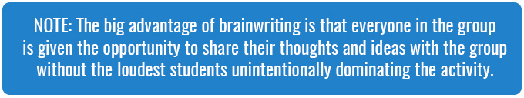
Give each student a copy of the Brainwriting Sheet (one half for each student) and invite each student to write down their ideas in response to the question on the sheet. Give students one minute to add their ideas. Once complete, have each student pass their ideas on to someone else, who reads the ideas and adds new ideas. Again, give students one minute to add their ideas. Repeat until all students have had the chance to add their ideas.
Step 2. Once groups have completed the brainwriting activity, invite them to view and discuss their list of ideas. Invite students to nominate their favourite ideas by:
- Drawing a star next to the idea they think is the most creative
- Drawing a smiley face next to the idea that they like best
Invite groups to share their most creative idea and the idea they liked the best with the class.
TIP: Keep a record of student ideas – these can be referred to later in this lesson or in other lessons in this unit.


Part D: Watching The 2040 Documentary
Step 1. Explain to students that they will now be watching 2040. Before watching, briefly read through the information on Critically Viewing a Documentary Film as a class. Encourage students to adopt an active approach to watching this documentary film, and to be mindful and aware of their own reactions to what they see, hear and feel.
Step 2. Ensure that students are settled and comfortable before starting the film. Close the blinds and give reminders about potential interruptions.
Step 3. To find out how you can watch the documentary, visit the 2040 website. If possible, allow the film to be played from start to finish, without interruption or discussion, so that your class has the opportunity to watch the documentary as the filmmaker intended.

Reflection
Invite students to complete the SEE THINK FEEL WONDER visible thinking routine on the Student Worksheet to synthesise their response to 2040 and the content/topics it covers. Make time for students to debrief their reflections after watching the film.

Extension
- Ask students to compare the solutions in the film with their own. What are the similarities and differences?
- Invite students to conduct further research into possible solutions to the challenges in the film.
- Investigate Doughnut Economics using the following clips :
  - Doughnut Economics by Kate Raworth (series of clips)
  - A healthy economy should be designed to thrive, not grow – TED Talk

Teacher Reflection
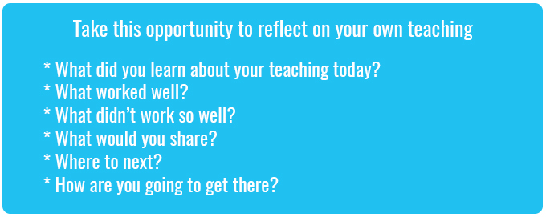

What’s Your 2040?
Join the Regeneration and take action for your 2040 now!
Go to the 2040 website to find out more about what you can do and to be inspired by what others are already doing. Take a picture of your actions and post it with the hashtag #whatsyour2040

