Reducing Our Carbon Footprint – Maths and Science – Grades 5 & 6 – Teacher Worksheet

Teacher Preparation
Learning Objectives: Students will…
- … understand about densities and masses of solids, liquids and gases
- … learn how CO₂ output by humans can be measured in kilograms produced ‘per annum’
- … learn that human CO₂ outputs can be reduced either through consuming less CO₂ or by absorbing or ‘drawing down’ CO₂ from the atmosphere
- … develop teamwork skills as they calculate household CO₂ footprints using addition, subtraction and multiplication of large numbers
- … realise that they can make a difference to global carbon dioxide levels by acting locally and encouraging others to do the same
Goals for Learning: Students can…
- … explain in simple terms why liquids, solids and gases have different densities
- … convert kilograms of CO₂ into a given approximate volume at room temperature, using multiplication
- … use provided data and successfully use addition, subtraction and multiplication to calculate and solve aggregate amounts of CO₂ for individuals, neighbourhoods and societies
- … express examples of local and household actions that can be taken to reduce their own individual carbon footprint and those of their families

Teacher content information: A 2018 study by The University of Melbourne on the thoughts and concerns of young people from Generations X and Y found the number one concern across both groups was lack of action around climate change. In particular, “Generation X worries what climate change will mean for their own children, while Generation Y is concerned about the impact on future generations” (The Educator). The report indicates that young people have a serious mistrust in the Government’s ability or willingness to tackle climate change.
Tackling climate change requires large-scale, systemic changes across all aspects of society. Simply aiming to reduce our C0₂ emissions is not enough: we need to rapidly decarbonise our planet. While this might sound challenging, the good news is we already have the knowledge and tools to do it.
2040 is an innovative feature documentary that looks to the future while focusing on what is happening now. Award-winning director Damon Gameau (director of That Sugar Film) embarks on a journey to explore what the future could look like by the year 2040 if we simply embraced the best solutions already available to us to improve our planet and shifted them into the mainstream.
The film will demonstrate to your students that we already have the solutions to climate change; we just need to take action to bring them rapidly into the mainstream. The 2040 documentary and curriculum package will support your students in turning this knowledge into positive action for a better future.
Find out how to see the film here. 2040 will only be available in cinemas for the first part of 2019 and you can make a group booking for your class at your local cinema during the film’s theatrical release which starts on May 23. These lessons have been designed with a media library to support teachers. The film will be available on video-on-demand and DVD later in 2019.
The film is the entry point to a global impact campaign that seeks to mobilize audiences to learn about, contribute to, advocate for and invest in regenerative solutions that improve the wellbeing of the planet, all people and all living systems.
To join the Regeneration and share your vision for 2040, see the website.

Watch the 2040 trailer:
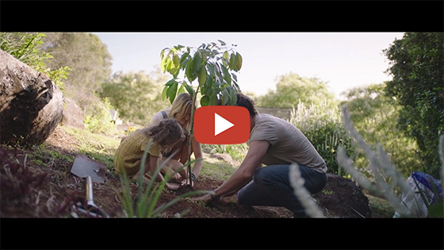
2040 – Official Trailer Password: 2040_EDU (https://vimeo.com/showcase/6167669/video/325372102)
Cool Australia, GoodThing Productions and Regen Pictures would like to acknowledge the generous contributions of Good Pitch Australia, Shark Island Institute, Documentary Australia Foundation, The Caledonia Foundation and our philanthropic partners in the development of these teaching resources.
Addressing misconceptions: Students often hear about the issue of global warming in the media, at home and at school. However, there are two striking observations we can make about the way in which young people hear about, and process, messages about this pressing global environmental issue.
- What is happening to our planet is almost always couched in terms of ‘doom and gloom’. Accompanying the discourse surrounding this issue is the sense that a rapidly warming climate is both inevitable and irreversible, therefore there is nothing we can do about it other than lie back and accept a cataclysmic fate.
- There seems to be a fundamental misunderstanding about what has actually caused global warming – in particular, the role of carbon dioxide and its human-induced increase in the atmosphere. Young people often perceive CO₂as a nasty, unstoppable pollutant choking up the atmosphere, quite unaware that CO₂ is actually a small but highly sensitive and naturally occurring component of Earth’s atmosphere. They are also generally unaware that if humans were to take immediate action, it is possible to draw down much of the human contribution to atmospheric CO₂ and so ameliorate its detrimental impact on our climate, oceans and surface temperatures on Earth.
The overall message for students in this lesson (and it’s precursor lesson, 2040 - The Math of Carbon - 5 & 6 is that mathematics, combined with technological application and determined environmental action, can change our planet’s fortune and turn around the outlook for current and future generations. As much as anything, success with our strategies for effective environmental solutions are an exercise in mathematical problem-solving. After all, it is hard to argue with the math!
Hot tip: This lesson requires basic knowledge of the principle of sustainability. If students are unfamiliar with this term or need clarity, consider sharing the following definition:
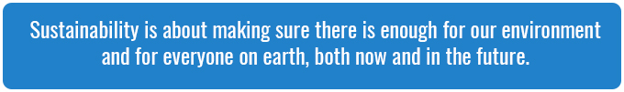
This factsheet can also help to provide background information about the principles of sustainability: Sustainability Factsheet.

Teaching Sequence
Work through this resource material in the following sequence:
15 minutes – Part A: The Weight of Greenhouse Gas
15 minutes – Part B: CO₂ in the Atmosphere: Australia vs. The World
25 minutes – Part C: Our Carbon Saving Household
10 minutes – Reflection
Worksheet Preview – Please click the button to Download / Print
Download / Print

Part A: The Weight of Greenhouse Gas
Step 1. If you completed the first lesson, 2040 - The Math of Carbon - 5 & 6, you might like to use the Summary slides to review the key points covered.
If you have not completed the first lesson in this Unit, 2040 - The Math of Carbon - 5 & 6, here are two short videos that explain climate change:
https://www.youtube-nocookie.com/embed/-n4A0BssFd0
Climate Change Explained in Less than 2 Minutes(https://www.youtube.com/watch?v=-n4A0BssFd0)
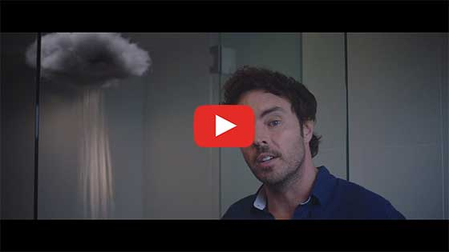
2040 – Exploring the Themes Password: 2040_EDU(https://vimeo.com/showcase/6167669/video/336503936)
Revise the following points with your class by way of introduction:
- Carbon Dioxide is not a large proportion of atmospheric gas, but it’s an important one. This is because CO₂ traps and holds heat in our atmosphere.
- We can graph a line graph that shows the increase in CO₂ concentrationssince about 1950 – and show that this corresponds with an increase in average temperatures as our atmosphere has warmed up;
- This is definitely messing with our climate. We really need to take action now by both reducing and ‘drawing down’ carbon in the atmosphere.
- Fortunately, there are various ways we can do this…
Step 2. Explain to students that today we’re going to look at a measure for CO₂emissions, that is, CO₂ that has been released into the atmosphere by human activities. This is often referred to by scientists as ‘CO₂e’ or ‘carbon dioxide equivalent’. Importantly, we can consider and measure the amount of CO₂ produced by each of us as individuals, and within our families or households.
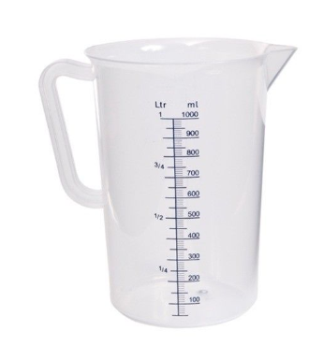
Let’s start with a container of water. This time have a container that can fit exactly one liter (1000 mL) in it:
For this demo, you’ll also need a one liter container of another denser substance (eg. pudding, a liter of small pebbles); a container of less dense substance (eg. penne or rigatoni dry pasta); and a liter of water to fill the container.
You’ll also need a kitchen measuring scale; the electronic ‘nutrition scales’ are the best to use as you can easily set them to zero with the container sitting on the scale. If you don’t have access to that sort of scale, you may just need to note and subtract the weight of the empty container.
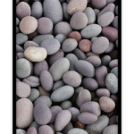 | 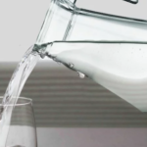 |  | 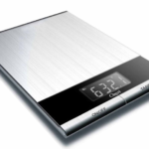
What we want to show students here is that different substances – liquids, solids, and gases – have different densities, which means they weigh more or less in the same given volume. As you work through this activity in the following steps, invite students to fill in the weights of each substance on the Student Worksheet.
Step 3. Set the nutrition scale to zero, then start with filling the liter container with water to exactly the 1000 mL mark – remind students that this is 1 Liter. Ask “What do we notice the weight is?” The weight of 1,000 mL of water is 1,000 grams – or exactly 1 kilogram. This is because we actually take the weight of 1 kg from exactly 1 Liter of water. Explain this to the students. Invite students to record this weight on the Student Worksheet.
Step 4. Now, you will be looking at the weight of some other substances – say, the pebbles. Fill the 1 liter container with pebbles, up to the 1 Liter mark. Now, what’s the weight? It should be a lot more than one kilogram. Invite students to record this weight on the Student Worksheet.
Ask students, “What do we notice about the weight now?”, then “Can anyone suggest why this is?”
After discussion, explain this is because the pebbles are a solid and are much denser than water, which is a liquid. This literally means that the molecules of rock in pebbles are much closer together, so there’s more ‘stuff’ in the pebbles within the same one liter volume.
Optional Extension: What is a molecule?
If this is a question your students ask – and it’s a great question – then a quick crash course in molecular physics might be just the thing.
- A molecule is a bundle of atoms that are bonded together by their chemical properties, to make up a chemical substance – such as water (‘H₂O’), carbon dioxide (CO₂) or simple sugars.
- An atom is a tiny particle made up from numbers of protons, neutrons, and electrons, that make up the chemical building blocks from which molecules are structured. For example, water molecules are made up from two atoms of Hydrogen and an atom of oxygen; carbon dioxide molecules are made up from a carbon atom bonded with two oxygen atoms; sucrose molecules are made up from much more complex bundles of carbon, hydrogen, and oxygen.
This 10-minute animation (https://www.youtube.com/watch?v=7jlZ1ADZ_ew) explains atoms and molecules as the chemical building blocks from which all matter is made.
Step 5. Ask for a prediction from students about the weight of the penne pasta (or other less dense substance) and have students record the actual weights in the space on the Student Worksheet.
Eg. “What do you think will happen with the weight of a liter of penne pasta?”
Weigh the liter of pasta (it should be much less than 1 kilogram), have students record it and then ask,
“Pasta is a solid… why is this so light?”
After discussion, reinforce that the reason that the pasta is so light is that the holes or gaps in the pasta shells contain air (which is a type of gas) and gas is much less dense than most liquids and solids at room temperature. In gases (such as the mix of gases that make up our ‘air’ at room temperature), the molecules are much further apart and so there is less ‘stuff’ in a given volume (such as one liter) of gas.
A simple diagram on the board can be drawn to illustrate this:
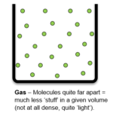
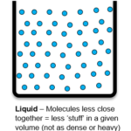
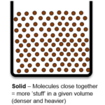

Step 3. To finish this section, explain that as a gas, CO₂ is not at all dense – but it does still have weight. This means that a whole kilogram of CO₂ would take up a lot of space.
In fact, let’s make it easy. Explain and/or write up onto the whiteboard:
“1 kg of CO₂ at room temperature (and not under any pressure, such as pushed into a gas bottle or cylinder) would take up the same space as a large container that measures:
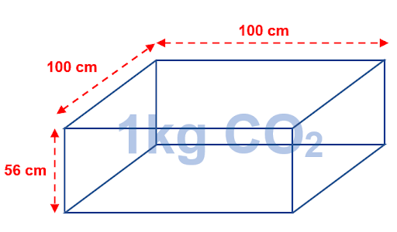
100 cm x 100 cm x 56 cm = 560 000 cm3
Note: This image can be downloaded here.
Step 6. At this point, you could take the opportunity to remind students of the calculation of cubic capacity (as shown above), and then have them convert this into a volumic measure. Remind the class that 1 cm³ = 1 mL in volume, and there is 1,000 mL in 1 Liter.
Ask students, “so, what would be the volume taken up by 1 kilogram of CO₂ (at normal room temperature), in Liters?’ Answer- 560,000 cm³ capacity = 560,000 mL volume = 560 Liters.
To give students an idea in practical terms, just 1 kg of CO₂ gas takes up the same amount of room as a large trunk of a car or a small refrigerator.
Optional Extension: The Carbon Cycle
If you would like to explore with the class how carbon behaves in the environment consider the following activity.
When CO₂ is ‘drawn down’ from the atmosphere – such as when it is absorbed by plants – it’s transformed by the process of photosynthesis into more stable molecular compounds. Oxygen from the CO₂ is released into the atmosphere and the carbon atoms are stored in more complex and stable molecular structures within solids such as sucrose (simple sugars).
When plants and animals die and break down on the surface of the Earth, or are burned, the carbon atoms are again oxidized and released back into the atmosphere as carbon dioxide. This process of carbon drawdown, sequestering and return into the atmosphere is known as the carbon cycle(https://www.alevelgeography.com/carbon-cycle/). You might like to share this video (https://www.youtube.com/watch?v=2Jp1D1dzxj8) with your students.
You might like to show students this picture from 2040: A Handbook for the Regeneration to demonstrate how carbon is stored and distributed:
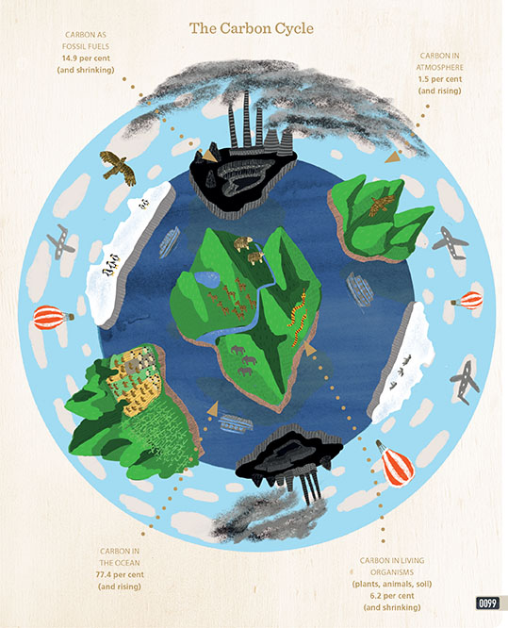

Part B: CO₂ in the Atmosphere: USA vs The World
Step 1. Now your class knows what the volume of a kilogram of CO₂ is, they can start thinking about just how much CO₂ is used by people daily – and also how much can be saved from going into the atmosphere through renewable energy technologies like solar energy, and incredibly how much can be absorbed by trees and other green plants. Explain to the class that thinking about our daily use of carbon is will be the next part of this class.
Step 2. Explain that you will be showing a clip from the documentary 2040 that explores energy use that actually helps solve some of the problems with carbon in the atmosphere that they have been exploring.
Challenge students to keep their eye out for the ‘ice cart’ at the start of the video. The load of ice on the back of this man’s cart is about the same volume as 1 kg of carbon dioxide, at room temperature – about 26 degrees Celcius,, or 78.8 degrees Fahrenheit.
Hint: Here is a video with quick and easy instructions for converting Celsius to Fahrenheit: https://www.youtube.com/watch?v=FMAymuRllog
Now, show this clip from 2040:
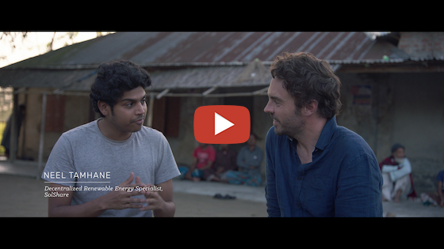
What’s Your 2040 – For Energy? Password: 2040_EDU(https://vimeo.com/showcase/6167669/video/336504721)
Step 3. Invite students to use the ‘Connect, Extend, Challenge’ framework on the Student Worksheet to summarize their thoughts, those of their partner and then those of the whole class, before proceeding.
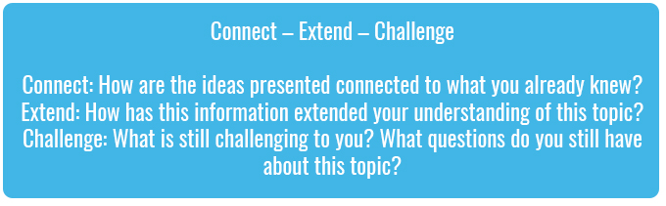
Take 3 to 6 minutes to conduct this session and summarize the class’s thoughts about the video on the board.
Step 4. Putting some metrics around the carbon footprint of the United States can be a bit depressing - and that’s NOT the intention of this lesson. The United States has a large carbon footprint at 15.5 metric tons (in 2016), (comparable to Australia where the filmmaker is from). We can however still do better in order to improve our carbon emissions to reduce our impact on the planet.
Hot Tip: Distinguishing between ‘metric tons’ and ‘tons’. Care should be taken here, especially if students are investigating mass or weights on the Internet, to draw the distinction between an Imperial ‘ton’ and a metric ‘ton’. The USA still routinely use the Imperial measure of ‘ton’, which is 2,000 pounds (another Imperial measure). A ‘metric ton’ refers to 1,000 kilograms. To convert USA Imperial tons into metric tonnes, we need to multiply by 0.907185; to reverse this (ie, tonnes into tons), multiply by 1.10231.
Explain to the class that according to 2014 figures from the World Bank, the world average carbon footprint is 4.9 metric tons. When you look at the CO₂ output of the average Bangladeshi in a year at only 460 kg (0.46 tons), our carbon footprint is massively disproportionate at 15.5 tonnes. We Aussies really need to start to shed our ‘Carbon Kilos’ – and fast. That is what your students will be working on today to build a better tomorrow.
Step 5. Start your explanation for your students by popping those three figures up on the board and/or showing them this graph from 2014:
- Average USA CO₂ output per year = 16.5 metric tons
- Average Aussie CO₂ output per year = 15.3 metric tons
- Average Swedish CO₂ output per year = 4.5 metric tons
- Average World CO₂ output per year = 4.9 metric tons
- Average Bangladeshi CO₂ output per year = 0.46 metric tons
(World Bank, 2014)
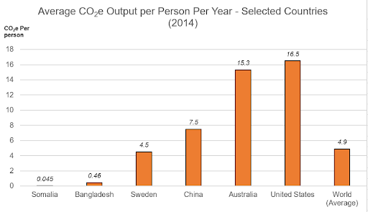
Ask for some comments from your class about these figures. Hopefully, your students will see that, in America, we consume more than our fair share of carbon-emitting energy, and that this implies we have an obligation to reduce this!
Step 6. At this point, ask the class: “When people want to lose weight, what can they do?”
Discuss this with students and then summarize the discussion into two main strategies:
- People can reduce the kilojoules (energy) going into their body, for instance by eating less, AND
- People can ‘burn off’ the existing stored kilojoules (energy) in their body by being active and getting regular healthy exercise (which is similar to drawing down carbon).
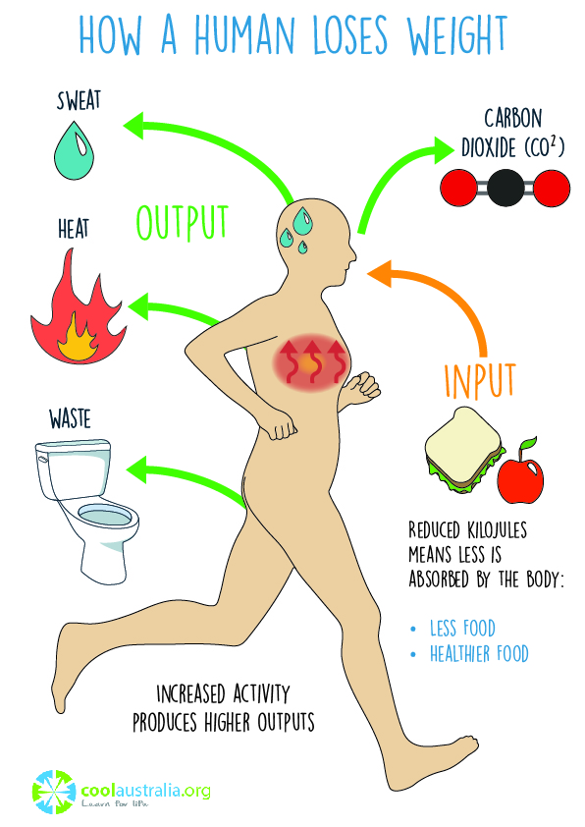
Explain to students that reducing our carbon footprint – the amount of CO₂ we’re responsible for putting into the atmosphere – like the process of an adult trying to gain a healthier weight:
- We can REDUCE the kilograms of CO₂ going into the atmosphere by consuming less energy and reducing our reliance on fossil fuels, AND
- We can DRAW DOWN the existing stored CO₂ going into the atmosphere by planting and protecting trees and green plants (which absorb carbon dioxide as they grow and photosynthesize).
Discuss with the class how, in the video, Bangladeshi neighbourhoods had found smart ways of working together to reduce their carbon dioxide emissions through solar energy sharing ‘mini-grids’. However, their reliance on fossil fuels in the first place is very low (not many Bangladeshis drive cars, for instance, and neither do they generate much electricity through coal or gas power plants).
Finally, explain to students that in the next activity, we’re going to play around with some things that CAN help us Americans both reduce our household carbon dioxide emissions, as well as draw down some of the CO₂ that we’ve already put into the atmosphere!
Worksheet Preview – Please click the button to Download / Print
Download / Print

Part C: Our Carbon Saving Household
Step 1. In this activity, students should ideally work in groups of 3 (one or two groups of 2 will be okay if three can’t work with your class numbers). This is because the average US household in 2016 had 2.5 people living there.
To start, each group should be given a ‘house’ (see ‘Our CO₂ Saver Household’ Worksheet), that shows that the average US household (with 2 to 3 persons) uses about 40 metric tons of CO₂ per year (including transport energy). For added ‘classroom dynamic’ (and to prevent ‘cheating’ later on), have each team write their names onto their ‘House’ and then pin it on the board out the front of the room.
Each team is also given the full first set of cards, the ‘CO₂ Saver Choice Cards & Facts’ (see Resources); there are 8 of them. Do not give the second page of this factsheet with the answers on it yet.
Explain to the class that, without access to the Internet, their teams must decide on which 4 of these strategies (maximum) their household is going to implement, in order to have the biggest reduction on their household’s carbon dioxide footprint.
Give teams about 5 minutes to decide on their 4 strategies. Once they have their 4, they can then come and stick their 4 strategies onto their household out the front.
Step 2. Now for the fun part. Once students have stuck their 4 selected strategies onto their household out the front, have them sit down again.
Hand out the 8 ‘CO₂ Saver Fact Cards’; give 1 card each to any 8 students selected at random i.e. one cut out fact card for each of the 8 selected students. In turn (starting with 1 and finishing with 8), have these students read out the fact on their card, and the subtraction instruction in red as well.
As each card is read out, have groups use working paper to work out both the cumulative CO₂ savings they are making with each of their 4 selected strategies, as well as the reduced total CO₂ footprint as they subtract each amount from their total.
Step 3. Finally, for fun (and checking), use the ‘Household CO₂ Calculator‘ Spreadsheet to work through the amount of CO₂, in kg per year, that can be deducted from their household (either because they have reduced OR drawn down atmospheric carbon), for each strategy. The graphic will show the effect of each strategy on the amount of CO₂ that can be saved from an annual average household carbon footprint of 40 000 kg (40 tonnes) per annum:
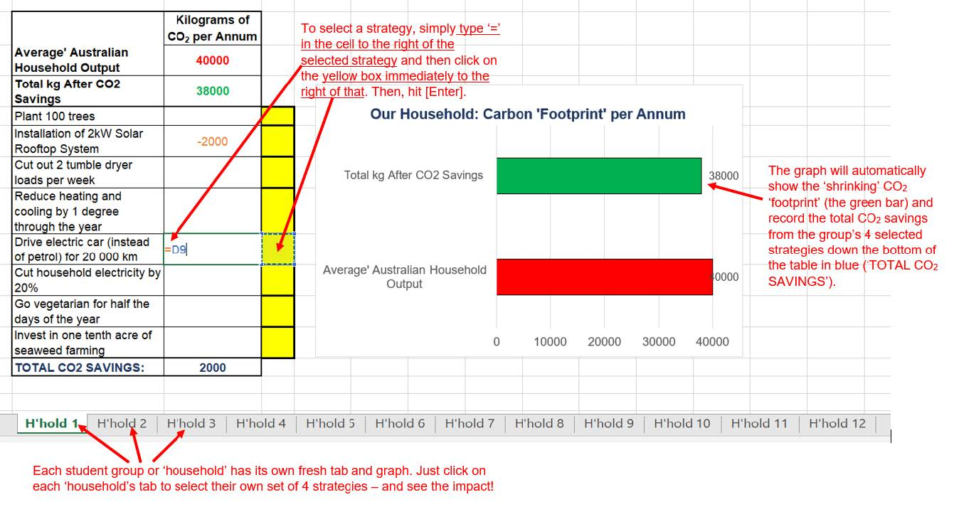
Note: The annotated graphic above can be downloaded, HouseholdCO2CalculatorDemo.
Step 3. Having calculated all teams’ CO₂ savings and reduced household per annum footprint, have the following discussion with students:
- What were the surprises here? Which CO₂ saving strategies were larger than you expected and which were smaller?
- What were the 4 most effective (biggest impact) strategies?
- Which strategies do they think would be the easiest for a household to implement? Why?
- Which strategies do they think would be the hardest for a household to implement? Why?
- How much CO₂ could a household save by implementing ALL 8 strategies? (Use the spreadsheet to show this!)
- Even though some of these strategies don’t seem to make a big difference overall, why is it still worth implementing them?
- If the ‘households’ in our game today were a neighborhood or small town, how many kilograms (and tons) of CO₂ could the neighborhood save altogether in a year? Optional: How many LITERS of CO₂ would this be? (Refer back to Part 1, showing that 1 kg of CO₂ at room temperature is = 560 Liters).

Reflection
Step 1. Reinforce for students the following main points:
- When compared with the rest of the world, Americans have a pretty large ‘carbon footprint’ because we produce more tons of CO₂ per person per year than most other people in other parts of the world – like Bangladesh.
- However, just like the community solar grids we were shown in Bangladesh in the video clip from 2040, we can implement simple household strategies, and use existing smart technologies, to both reduce our CO₂ output and to draw down the existing CO₂ in the atmosphere.
To conclude the lesson, challenge students and have a class discussion around the following points:
- Which two, three, maybe four of the strategies mentioned in Part C could you introduce to your home? What changes could your household and family make, even if it only makes a little difference?
- What if each person in the class’s household was able to reduce their carbon footprint by just one metric ton (1,000 kg) of carbon dioxide in a year?
- How much carbon saving would that be in the class altogether?
- What about if each class member planted 10 trees? How much carbon would we draw down as a group?
- What if the whole school got involved – how much then?
Step 2. Perhaps your class – or school – might like to build a ‘carbon saving graph’ for the classroom wall, to measure just how much carbon savings they can make as a group.
Students could research and estimate the kg of CO₂ per person different environmental measures could make, and have these submitted to a supervising teacher or group of students, and then recorded as carbon savings on the group chart or graph.

Differentiated Learning
Extension – Students could undertake a detailed carbon footprint audit at home and report back to the class. To do this they could use the ‘Ecological Footprint Calculator’ (https://www.footprintcalculator.org), or a similar website, and then simplify the components of their home’s carbon emissions budget in a column graph presented to the class.
Provisions for Learning Support –
- Pair students of differing ability in the warm-up and the whole-class group work activity to assist students experiencing difficulty with addition and subtraction of the carbon dioxide kilograms.
- Assist students to break down larger numbers, such as kilograms per annum subtracted and added to overall ‘household’ CO2 footprints – eg:
40,000 – 180
= 40,000 – 100 – 80
= 39,900 – 80
= 39,820.
Hint: Using drawn number lines and bottom-up 100s charts can also assist with these number operations.
- Practice multiplying and dividing by 1,000 to convert between kilograms and metric tons. This will support students experiencing difficulty with unit conversions, eg. ‘How many kgs in 34 tons? → 34 x 1,000 = 34,000 kg’; ‘How many metric tons in 3,450 kg? → 3,450/1,000 = 3.450 (or 3.45) metric tons.’

Take It Further
To expand on student’s learning in this activity, consider following up with this lesson; Taking Action For Your 2040.

Teacher Reflection


What’s Your 2040?
Record your students’ work in their communities with the hashtag #whatsyour2040 and share their visions in the ‘2040: The Regeneration’ Facebook Group.
The 2040 crew would love to see your class’ work.

