The Maths of Carbon – Science & Maths – Grades 5 & 6 Teacher Worksheet

Teacher Preparation
Learning Objectives: Students will…
- … understand that carbon dioxide is a gas that naturally exists, although in very small proportions, as a component of Earth’s atmosphere
- … learn how atmospheric gases (such as CO₂) are measured in ‘parts per million’ and also how to convert parts per million into a percentage measurement
- … learn how to construct and interpret a time series graph and use appropriate vocabulary to explain the changes in a given quantity or phenomena over time
Goals for Learning: Students can…
- … identify several key gases in the Earth’s atmosphere and describe the way they are measured in ‘parts per million’
- … convert parts per million into a percentage measurement
- … construct a time series graph from a simple data set

Teacher content information: A 2018 study by The University of Melbourne on the thoughts and concerns of young people from Generations X and Y found the number one concern across both groups was lack of action around climate change. In particular, “Generation X worries what climate change will mean for their own children, while Generation Y is concerned about the impact on future generations” (The Educator). The report indicates that young people seriously mistrust the Government’s ability or willingness to tackle climate change.
Tackling climate change requires large-scale, systemic changes across all aspects of society. Simply aiming to reduce our CO₂ emissions is not enough: we need to rapidly decarbonise our planet. While this might sound challenging, the good news is we already have the knowledge and tools to do it.
2040 is an innovative feature documentary that looks to the future, while focusing on what is happening now. Award-winning director Damon Gameau (director of That Sugar Film) embarks on a journey to explore what the future could look like by the year 2040 if we simply embraced the best solutions already available to us to improve our planet and shifted them into the mainstream.
The film will demonstrate to your students that we already have the solutions to climate change; we just need to take action to bring them rapidly into the mainstream. The 2040 documentary and curriculum package will support your students in turning this knowledge into positive action for a better future.
Find out how to see the film here. 2040 will only be available in cinemas for the first part of 2019 and you can make a group booking for your class at your local cinema during the film’s theatrical release which starts on May 23. These lessons have been designed with a media library to support teachers. The film will be available on video-on-demand and DVD later in 2019.
The film is the entry point to a global impact campaign that seeks to mobilize audiences to learn about, contribute to, advocate for and invest in regenerative solutions that improve the wellbeing of the planet, all people and all living systems.
To join the Regeneration and share your vision for 2040, see the website.
Watch the 2040 trailer:
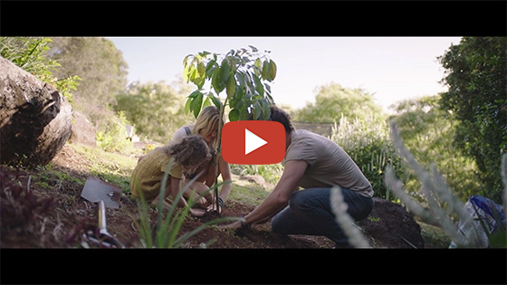
2040 – Official Trailer Password: 2040_EDU (https://vimeo.com/showcase/6167669/video/325372102)
Cool Australia, GoodThing Productions and Regen Pictures would like to acknowledge the generous contributions of Good Pitch Australia, Shark Island Institute, Documentary Australia Foundation, The Caledonia Foundation and our philanthropic partners in the development of these teaching resources.
Addressing misconceptions: Students often hear about the issue of global warming in the media, at home and at school. However, there are two striking observations we can make about the way in which young people hear about, and process, messages about this pressing global environmental issue.
- What is happening to our planet is almost always couched in terms of ‘doom and gloom’. Accompanying the discourse surrounding this issue is the sense that a rapidly warming climate is both inevitable and irreversible, therefore there is nothing we can do about it other than lie back and accept a cataclysmic fate.
- There seems to be a fundamental misunderstanding about what has actually caused global warming – in particular, the role of carbon dioxide and its human-induced increase in the atmosphere. Young people often perceive CO₂as a nasty, unstoppable pollutant choking up the atmosphere, quite unaware that CO₂ is actually a small but highly sensitive and naturally occurring component of Earth’s atmosphere. They are also generally unaware that if humans were to take immediate action, it is possible to draw down much of the human contribution to atmospheric CO₂ and so ameliorate its detrimental impact on our climate, oceans and surface temperatures on Earth.
The overall message for students in this lesson (and its optional follow-up lesson, 2040 – Reducing Our Carbon Footprint – 5 & 6, is that mathematics, combined with technological application and determined environmental action, can change our planet’s fortune and turn around the outlook for current and future generations. As much as anything, success with our strategies for effective environmental solutions are an exercise in mathematical problem-solving. After all, it is hard to argue with the math!

Teaching Sequence
Work through this resource material in the following sequence:
20 minutes – Part A: The Issue of Atmospheric Carbon
10 minutes – Part B: The Air That We Breathe
25 minutes – Part C: Tracking Earth’s Atmospheric Carbon Record
10 minutes – Reflection
Worksheet Preview – Please click the button to Download / Print
Download / Print

Part A: The Issue of Atmospheric Carbon
Step 1. Show the following clip from the documentary 2040:
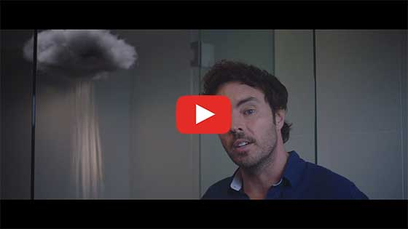
2040 – Exploring the Themes Password: 2040_EDU(https://vimeo.com/showcase/6167669/video/336505203)
While students are watching, invite them to complete the See, Hear, Wonder activity on the Student Worksheet.


Step 2. After viewing, lead the students in completing the following Think, Pair, Share activity on the Student Worksheet:
- Column A – There were many ideas presented in this clip, by the narrator, about the problem we face today regarding the Earth’s atmosphere. What THREE ideas did you find most interesting?
- Column B – Share your thoughts in column A with a partner and note down anything new.
- Column C – What were some ideas shared in the class discussion that you hadn’t considered before?
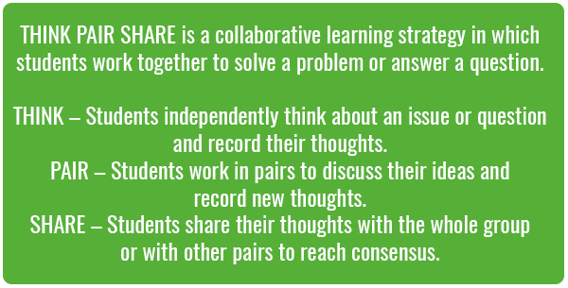
Take 3 to 6 minutes to conduct this session and summarize the class’s thoughts about the video on the board.
Step 3. This interactive graph (https://www.temperaturerecord.org/) from The 2° Institute shows an increase in anomalies of the global average temperature record since about 1900 and the overall increase in fluctuations in temperatures away from the long term global average since the 1960s. Show this graph to students and briefly discussed.
Hot tip: For a detailed interpretation of this graph, refer to the Global Temperature Record Factsheet.
Worksheet Preview – Please click the button to Download / Print
Download / Print

Part B: The Air That We Breathe
Step 1. Let’s start by giving students an idea of what ‘parts per million’ means. We’ll do this by looking at the percentages of gases in our atmosphere. This will help students gain an understanding of why carbon dioxide is such a big deal – and why the ‘Math of Carbon’ matters.
Place an empty glass or measuring beaker that is marked clearly into 10 intervals on a flat surface where all students can see it.
Hot tip: You can take a tall glass and mark it yourself into ten increments, like this: 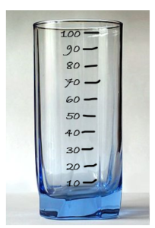 Image Credit: Creative Commons, (source)
Have a container filled with either water or, for effect, colored liquid.
- Ask students, “What would 10% look like in this glass?” After receiving several answers, show them by filling the glass to the first (10%) increment.
- Then ask, “What would 50% look like?” (repeat the procedure by filling to halfway); then “What would 100% look like?” (fill the glass all the way up).
- Then ask students – “How do we calculate ‘1%’?”
After a brief discussion, remind students, if needed, that ‘1%’ is literally 1 out of 100. So, to find 1% of something, we calculate (1/100) x (the amount).
Importantly, ask students if they can figure out ‘1% of a million’. They can use a calculator if they’d like to.
Show students on the board that this is calculated as:
1⁄ 100 x 1 000 000 = 10 000
(or show the class on a digital calculator up on the electronic whiteboard if you have one).
“This means that 1 percent of one million is the same as ’10 000 parts per million’.”
Teaching Tip: Multiplying and dividing whole numbers by units of ten is a skill best taught alongside the rest of your teaching of multiplication and is a whole lesson – or series of lessons – in and of itself. This is because while many students understand place value as it relates to whole numbers, they struggle to apply this concept to decimal numbers. This is often because they have yet to grasp that decimal numbers are indeed fractions – in parts of tenths, hundredths, thousandths and so on. This article by Anne Roche (https://files.eric.ed.gov/fulltext/EJ891799.pdf) explains how to assist students to make sense of decimal place value, in a ‘game-ified’ context.
Step 2. Explain to students that our lesson today is going to be looking at the amount of some important gases in the atmosphere:
- “In the clip from the film ’2040’, the narrator talked about ‘parts per million’ of gases in the Earth’s atmosphere. This really means the percentages of gases in the atmosphere.
- “Scientists use the measurement ‘Parts per Million’ (abbreviated as ‘PPM’) as it’s a little easier to say and explain, especially when we’re talking about very large volumes of things – such as Earth’s atmosphere!”
If needed, show this short clip to help students better visualise the concept of ‘parts per million’.

How to Visualise One Part per Million (https://www.youtube.com/watch?v=aa-m8a-jZ0k&vl=en)
Step 3. Empty the marked glass back into the original container, then put up the following list on the board and explain to students that these are some of the important gases (but not the only gases) that make up our atmosphere. You can leave out the chemical symbols for each gas if you wish.
- Oxygen (O₂)
- Carbon Dioxide (CO₂)
- Water (H₂O)
- Nitrogen (N₂)
- Argon (Ar)
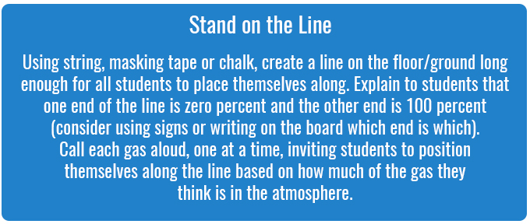
After the students have had their guesses, write the following percentages next to the list of gases:
- Oxygen (O₂) 20%
- Carbon Dioxide (CO₂) 0.04% (explain that this means much less than 1% – it’s only ‘four hundredths’ of one percent)
- Water (H₂O) 0.5% (about)
- Nitrogen (N₂) 78%
- Argon (Ar) 0.9% (explain that this is less than 1% – that is, it’s ‘nine-tenths’ of one percent)
Hot tip: You could also do this activity as a matching exercise, like so:
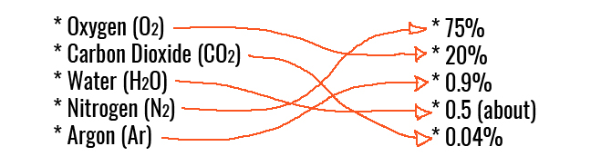
Step 4. Repeat the container activity using these percentages.
- Nitrogen – 78% – or 780 000 parts per million (fill the glass to about 78%);
- Oxygen – 20% – or 200 000 parts per million (fill the glass to about 98%);
- Argon – 0.9% – or about 9 000 parts per million (fill the glass to about 99%);
- Water – 0.5% – or 5 000 parts per million (fill the glass to about 99.5%);
- Carbon Dioxide – 0.04% (splash a tiny dab of liquid into the top of the glass)
Hot tip: You might like to try doing this activity with different coloured rice (or similar). It will help students see each percentage as it is added and also help to illustrate the concept of ‘parts per million’ because there are many grains of rice in the container.
Step 5. Have students fill in the below table on the Student Worksheet, calculating the parts per million of each gas, based on the percentages provided. Some assistance and scaffolding may be needed for some students here.
Name of Gas | Amount in Atmosphere – as ‘Parts per Million’ (PPM) | Amount in Atmosphere – as a Percentage (%)
Nitrogen | 780 000 | 78 %
Oxygen | 200 000 | 20 %
Argon | 9 000 | 0.9 %
Water | 5 000 | 0.5 %
Carbon Dioxide | 400 | 0.04 %
Reference: Pidwirny, M. (2006). “Atmospheric Composition”. Fundamentals of Physical Geography, 2nd Edition. https://www.physicalgeography.net/fundamentals/7a.html
To finish this section, explain the following:
- Carbon dioxide gas really makes up only a tiny proportion of the gases we have in our earth’s atmosphere. However, it has an enormously important job: It holds heat (or ‘radiation energy’) from the sun in our atmosphere, so the surface of the earth doesn’t freeze. However, its tiny amounts – and the important job it does retaining the sun’s heat – also means that the warmth of the earth’s atmosphere is VERY sensitive to changes in the amount of carbon dioxide.
Worksheet Preview – Please click the button to Download / Print
Download / Print

Part C: Tracking The Earth’s Atmospheric Carbon Record
Step 1. In this activity, we’re going to make a large, representation of a graph showing the changes in carbon dioxide in Earth’s atmosphere over the last 1,000 years. Tell students we’re going to see what that looks like by making our own whole-class graph together.
You and your class will need to find a large blank whiteboard, window or a large wall in the classroom or in a hallway close by. You’ll need to be able to write or draw on this space, so arm yourself with a whiteboard marker or some chalk.
You’ll also need a pad of sticky notes so your students can write on them and then stick their data up to make the ‘graph’.
Display the ‘CO₂ Data Table’ (below) so students can see it. Allocate each student in your class or group to one (or more) data rows (or ‘data points’). There are 28 data rows altogether; for classes or groups smaller than 28, allow some students to have more than one data row to their name.
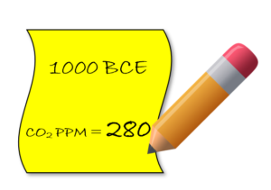
The CO₂ Data Table below provides measurements of the amount of carbon in the atmosphere, expressed as ‘Parts per Million’ (PPM), on year dates between 1000 BCE (Before Common Era) and 2019 BCE*.
Write students’ names next to the rows allocated to then – then have students write each of their allocated data points onto a separate sticky note like shown.
NOTE: We have mixed up the dates on purpose!
YEAR (BCE) | Atmospheric CO₂Concentration (PPM) | Student/group name
1200 | 284
1850 | 285
1700 | 277
1950 | 311
1725 | 277
1000 | 280
1750 | 277
1550 | 283
1875 | 289
1400 | 280
1100 | 283
1900 | 296
1600 | 276
1150 | 284
1300 | 283
2019 | 412
1800 | 283
2000 | 367
1650 | 276
1500 | 282
1050 | 281
1275 | 282
1350 | 282
1925 | 305
1825 | 284
1450 | 281
1775 | 277
1250 | 282
*(Scientists are able to measure this by drilling down into the ice in the Antarctic and Arctic to make ‘ice cores’. This allows them to study the chemical composition of ice as it was laid down over thousands of years, and so determine what was going on in the atmosphere during each ‘age’).
Once all the students have at least one sticky note each, ask the following questions of the group:
- “What is the oldest year date we have?” – 1050 (after this has been worked out, have this person stand up).
- “Who has the latest or most recent date?” – 2019 (have this person also stand up).
Step 2. Invite these two students to walk to the wall or board and stick their dates at the bottom left-hand corner (oldest) and the bottom right-hand corner (latest) of the board, wall or window.
Then, draw a line just above these sticky notes – this will become the horizontal axis for your class’s graph.
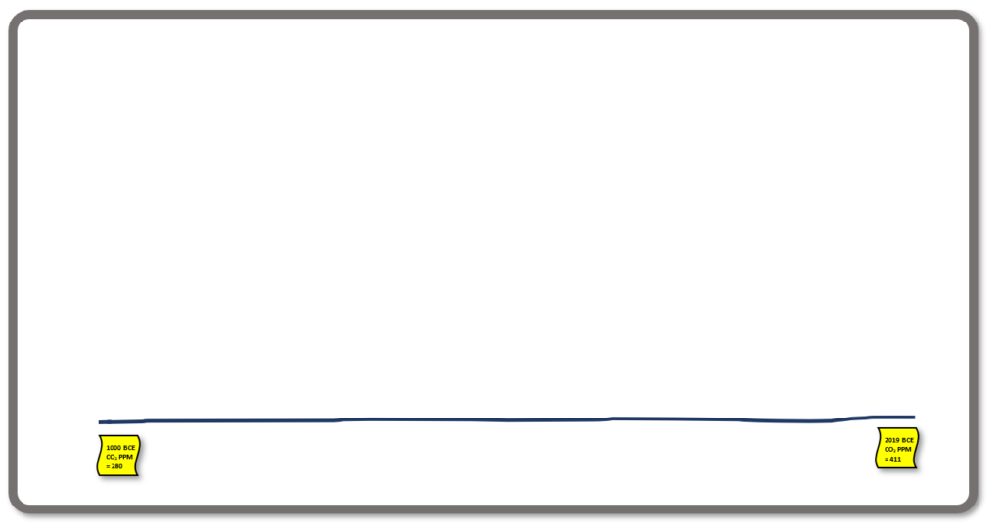
Now, have the class work out how we could place dates along the timeline you have drawn using regular or ‘equal’ intervals. “How could we do this?” Have students work out a strategy, and work with them (by scaffolding and prompting) to mark suitable date intervals onto the board or wall.
Once this is done, have students stick their sticky notes along their appropriate place on the ‘timeline’ they have made along the wall or board.
Hot tip: You might like to do this activity outside drawing the axis with chalk or strings. You could have students stand at their data point or lay down sports cones. For an extra challenge, get them to stand in the right spots on the graph WITHOUT talking.
Next, have the class look at the highest and the lowest CO₂ ‘PPM’ levels.
- “What is the highest?”
- “What is the lowest?”
Explain that to make a graph, we will also need to have a vertical scale – so stick the highest card up high on the board (still in line with its date on the horizontal axis!), and stick the lowest CO₂ value down lower (and also in line with its horizontal axis position).
Next, discuss with the class how we could make the vertical axis between those two values:
- “What should be the lowest value on the vertical axis?”
- “Do we need to start with zero at the bottom? Why/Why not?”
- “If we don’t start at zero on our vertical axis, what do we need to be careful of?”
- “How can we mark out regular intervals on the left-hand side of our ‘graph’, making sure our ‘increments’ are even… and why is this important?”
After your discussion, mark out the vertical axis of the graph.
Finally, have students move their sticky notes upwards until they are in the right vertical position, matching up with the new axis you have drawn up the left-hand side of the ‘graph’. Your class should have something that looks like this:
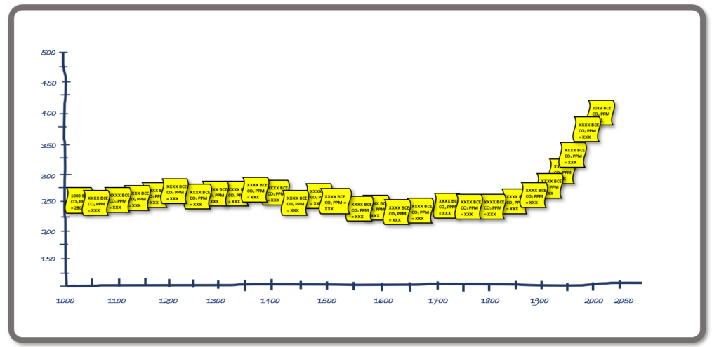
Make sure you snap a picture of your class’s terrific graph and then have students return to their regular learning space or classroom. Maybe you could even print out the photo of the graph and publish it on the learning space wall.
Step 3. Having finished off the graph (and maybe making the odd tweak or adjustment), use the following class questions as your students stand around looking admiringly at the results of their teamwork. Use these to ‘prod and promote’ discussion:
- “What kind of graph is this?” (Line graph)
- “How is this different from a column graph?” (Column graphs have separate categories of data that we compare with one another. A line graph shows changes in one thing, usually over time, as a continuous series)
- “Why is this type of graph being used?” (Because we’re showing something changing gradually over time – not separate categories of things such as we would show in a column graph)
- “What is shown on the horizontal and vertical axes of this graph?” (Horizontal – years since 1000 BCE up until 2019; Vertical – CO₂ in the atmosphere as parts per million (PPM). Have a student write these labels on the graph)
- “What label or heading could we give this graph?” (Compose a suitable heading with student input, then write it above the graph on the wall or board)
- “What does our graph tell us? What information does it give?” (That atmospheric CO₂ in the Earth’s atmosphere has been pretty stable for the past 1000 years (and more!!), however, there has been a dramatic increase since the mid-1900s)
- “Thinking about the video we have watched today, can we explain some possible reasons for this trend?” (Refer back to the video – largely, this has been due to human activities burning fossil fuels and releasing large amounts of stored carbon into the atmosphere. Some explanation of the fact that coal, in particular, is stored carbon as it is made out of millions of years’ worth of compressed trees and carbon-based remains of other living things).

Reflection
At this point, it will be tempting for your students to express a sense of being overwhelmed. CO₂ in the atmosphere and global warming seems like a big and unstoppable problem!
Allow your students to complete the Think, Feel, Wonder activity on the Student Worksheet. Acknowledge their concerns as valid. Then remind (or inform) them that we have a few powerful solutions at our disposal:
- Trees and Plants (including other carbon-storing organisms such as seaweed) actually absorb carbon dioxide, ‘drawing it down’ from the atmosphere;
- Renewable energy sources – such as rooftop solar systems – significantly reduce the amount of carbon dioxide produced by our households; and
- Reducing our energy consumption – by using fewer electrical appliances (such as tumble dryers and extra freezers), we can significantly reduce the volume of CO₂ our household or family releases into the atmosphere.
In the following lesson, 2040 – Reducing Our Carbon Footprint – Years 5 & 6, we’re going to look at ways in which we can help to ‘draw down’ some of the Earth’s atmospheric CO_{2.} We’ll use maths to put some numbers around how great a difference some of the strategies can actually make – and so prove that mathematics really can help save the planet.

Differentiated Learning
Extension –
1. Students could work further through the 2º Institute website(https://www.2degreesinstitute.org/) and explore the graphs and data they collect on global temperatures, atmospheric and oceanic changes that are impacting global climates and environments. In particular, students could work through the following Inquiry Questions:
- What is a ‘carbon footprint’?
- What is the difference between carbon, ‘CO₂’ and ‘CO₂e’?
- What are the main components of a carbon footprint? Draw a table that summarises these components, including the amount of CO₂e each of these components contributes to overall human CO₂ emissions, measured in ton of CO₂e per person per year.
- Use the data and graphics on this website to construct a column graph for the classroom wall showing the main components of our carbon footprint in societies such as Australia and North America.
2. The images in this article from Anthropocene Magazine (https://www.anthropocenemagazine.org/2016/02/visualizing-carbon/), provide a good visual for the amount of carbon dioxide produced by the US, and by various US cities. Find carbon emissions data for your area or your school, and challenge students to create their own visual expression of what that carbon would look like if it were visible.
3. For additional information on carbon consider showing students the following clip from 2040, Soil Carbon Demo Password: 2040_EDU(https://vimeo.com/336508523)
Provisions for Learning Support –
- Pair students of differing ability in the warm-up and the whole-class graphing activity to assist students experiencing difficulty to gain support from peers with a stronger understanding
- Use simple scales (such as number lines or rulers) and timelines prior to constructing the graph to show evenly spaced increments and why this is important for accurate measurement. One-to-one correspondence on scales, timelines and graphical increments is an important precursor to understanding many-to-one correspondence (such as in the vertical axis in this graphing activity)
- Assisting students to break down larger numbers, such as the ‘parts per million’ measurement of CO2, or year dates between labeled increments (eg. ‘1350 BCE’), using place value strategies. For example, ‘we need to find the number ‘275’ on this axis. Let’s break down ‘275’… firstly, how many hundreds? Okay, let’s find 200… Now, how many tens?…” etc.

Teacher Reflection


What’s Your 2040?
Record your students’ work in their communities with the hashtag #whatsyour2040 and share their visions in the ‘2040: The Regeneration’ Facebook Group.
The 2040 crew would love to see your class’ work.

