The Maths of Carbon – Science & Maths – Grades 5 & 6 – Student Worksheet
Thought starter: What’s the deal with Carbon Dioxide? Surely an invisible, tasteless and smell-less gas can’t really be such a drama? Can it?

The Issue of Atmospheric Carbon
Watch this clip:
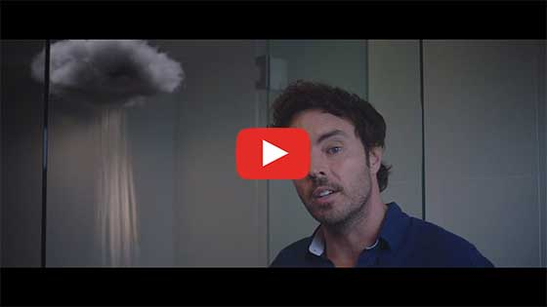
2040 – Exploring the Themes Password: 2040_EDU(https://vimeo.com/317186740)
While you’re watching, complete the table below.
SEE – What did you see as you watched this video? | HEAR – What did you hear the narrator talk about in the video? | WONDER – What questions arose as you watched?
After watching, complete Column A. Then wait for further instructions.
- Column A – There were many ideas presented in this clip, by the narrator, about the problem we face today regarding the Earth’s atmosphere.
What THREE ideas did you find most interesting?
- Column B – Share your thoughts in column A with a partner and note down anything new.
- Column C – What were some ideas shared in the class discussion that you hadn’t considered before?
Column A | Column B | Column C
1.

2.

3.
Worksheet Preview – Please click the button to Download / Print
Download / Print

The Air That I Breathe…
In the table below, list each of the main gases in our atmosphere as mentioned by your teacher.
After chatting with your class, then list the amount of that gas as a proportion of the total atmosphere – first, as ‘parts per million’ (PPM) and then as a percentage:
(Remember, to calculate a percentage (%) from ‘Parts per Million’ (PPM): PPM ⁄ 1 000 000x 100 = ______ % )
Name of Gas | Amount in Atmosphere – as ‘Parts per Million’ (PPM) | Amount in Atmosphere – as a Percentage (%)
 |  | %
 |  | %
 |  | %
 |  | %
 |  | %
Optional – If the Earth’s Atmosphere was a glass of frozen slushie drink, and each gas was a separate coloured ‘flavour’ draw and label the components in the glass! (Remember, in the real atmosphere, all the gases are mixed in together – not in layers!)
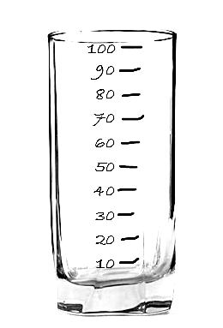

Reflection
After completing the graphing activity, complete this activity.
THINK – What are some thoughts you have about the activities and data in this lesson? | FEEL – How do you feel about what you have learned in this lesson? | WONDER – After this lesson, what are you still wondering about?
Write three important ideas that you will take away from this lesson:
1.

2.

3.

