Understanding Persuasion English Grades 8 & 9 Teacher Worksheet

Teacher Preparation
Learning intentions: Students will…
- … examine how persuasive devices can be used to express a point of view and influence an audience
- … explore how futuristic thinking can assist in imagining solutions to current environmental problems
- … practice applying persuasive devices to promote their visions for the future and learn how to give constructive feedback
Success criteria: Students can…
- … identify persuasive techniques used in the film
- … analyse the effectiveness of persuasive techniques for their intended purpose
- … plan and create works using different persuasive techniques with the same intended message as the original
- … create futuristic texts based on stimulus material


Teacher content information: A 2018 study by The University of Melbourne on the thoughts and concerns of young people from Generations X and Y found the number one concern across both groups was lack of action around climate change. In particular, “Generation X worries what climate change will mean for their own children, while Generation Y is concerned about the impact on future generations” (The Educator). The report indicates that young people have a serious mistrust in the Government’s ability or willingness to tackle climate change.
Tackling climate change requires large-scale, systemic changes across all aspects of society. Simply aiming to reduce our C0₂ emissions is not enough: we need to rapidly decarbonise our planet. While this might sound challenging, the good news is we already have the knowledge and tools to do it.
2040 is an innovative feature documentary that looks to the future, while focusing on what is happening now. Award-winning director Damon Gameau (director of That Sugar Film) embarks on a journey to explore what the future would look like by the year 2040 if we simply embraced the best solutions already available to us to improve our planet and shifted them into the mainstream.
The film will demonstrate to your students that we already have the solutions to climate change; we just need to take action to bring them rapidly into the mainstream. The 2040 documentary and curriculum package will support your students in turning this knowledge into positive action for a better future.
Find out how to see the film here. 2040 will only be available in cinemas for the first part of 2019 and you can make a group booking for your class at your local cinema during the film’s theatrical release which starts on May 23. These lessons have been designed with a media library to support teachers. The film will be available on video-on-demand and DVD later in 2019.
The film is the entry point to a global impact campaign that seeks to mobilise audiences to learn about, contribute to, advocate for and invest in regenerative solutions that improve the wellbeing of the planet, all people and all living systems.
To join the Regeneration and share your vision for 2040, see the website.
Watch the 2040 trailer:
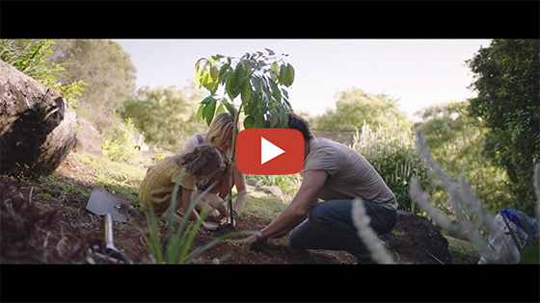
2040 – Official Trailer
Password: 2040_EDU (https://vimeo.com/showcase/6167669/video/325372102)
Cool Australia, GoodThing Productions and Regen Pictures would like to acknowledge the generous contributions of Good Pitch Australia, Shark Island Institute, Documentary Australia Foundation, The Caledonia Foundation and our philanthropic partners in the development of these teaching resources.

Teaching Sequence
Work through this resource material in the following sequence:
30 minutes – Part A: Recapping Persuasion
40 minutes – Part B: Analysing Persuasive Devices
40 minutes – Part C: Your Future Vision
2 minutes – Reflection

Part A: Recapping Persuasion
Step 1. In this activity, students will have the opportunity to notice how persuasive language is used unconsciously in everyday language. By talking about a topic everyone has in common but aren’t always in agreement about (in this case, food), students get to rehearse persuasive devices and get immediate feedback from their ‘audience’ as to the effectiveness of their language.
Ask students to form pairs. Have one student per pair nominate themselves as Person A by raising their hand. The other student is Person B. Lead them through the following activity in steps:
- Say: ‘Person A, I want you to imagine a food you really love. Picture it clearly in your mind and then imagine all the tastes and textures of the food. Think about how it smells and what all your favourite things are about this food.’
- Say: ‘Now turn to Person B and tell them why your favourite food is the best food in the whole world. You have 30 seconds to convince your partner and to get them excited about your chosen food.’
- Set a timer for 30 seconds and call STOP when time is up. Ask Person Bs to raise a hand if they got excited about the food that was described. Then ask them to raise their hand if they weren’t too keen on the description or were unconvinced.
- Say: ‘Person B, I now want you to imagine a food that you really hate. Think about what it is about this food that makes you want to avoid it and how it makes you feel.’
- Say: ‘Ok, now tell Person A all the reasons why you think this food is awful and try to convince them to avoid eating it ever again. You have 30 seconds.’
- Set a timer for 30 seconds and call STOP when time is up. Ask Person As to raise a hand if they were convinced not to eat the food just described to them, or at least if they thought they made a strong argument.
- Invite the pairs to discuss with each other what kind of language they noticed each person using. Allow one minute for this.
Optional: You might like to ask students to share some specific words and write them up on the board. You can categorise these words; consider using the Persuasive Language Factsheet to guide you.
Step 2. Show students this document (Persuasive Writing Presentation) and read through it with them. Ask students for examples of each type of persuasive technique from the conversation they just had. You might like to list these examples on the board in a table like this:
Appeal to reason | Appeal to character | Appeal to emotion
Step 3. Distribute one copy of Student Worksheet to each student and talk through the list of persuasive devices listed (also see below). Invite students to suggest examples that are guided by the information in the Description column. Use this time as an opportunity to clarify any concerns or confusion students might have about the persuasive devices listed below:
Persuasive Device | Description
Power of Three | Including lists of three items/reasons in your writing.
Emotive Language | Words, phrases and imagery that create an emotional response.
Rhetorical Questions | Questions to get your audience thinking – they don’t require an answer.
Say Again (repetition) | Repeating the same word, phrase or idea more than once for emphasis.
Undermine opposing views | Criticise the opposing argument.
Anecdote | Include little stories to illustrate a point.
Direct Address | Involve your audience by speaking to them directly using personal pronouns and shared experience.
Exaggeration | Being over-the-top to get a point across.
Step 4. Now explain to the students they are about to view a clip from a feature-length documentary; 2040. Tell them it is a film about climate change that imagines what the future might look like if we apply currently existing solutions and technologies to help meet the challenges of climate change.
Explain to students that as they watch, they should be focusing on what the purpose of this film might be; for example, how is the film-maker/narrator (Damon) wanting the audience to respond?
Share the following clip with students:
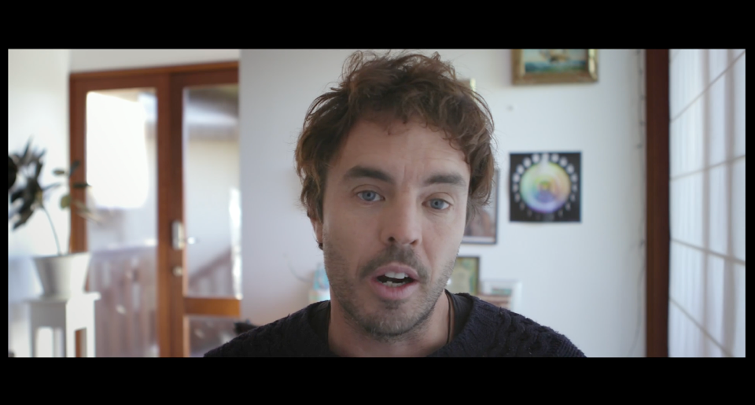
2040 – Setting up the Journey
Password: 2040_EDU
(https://vimeo.com/336505203)
Once complete, invite students to navigate to the table below (which is also available on the Student Worksheet). Allow them a few minutes to complete the table. Some students may find it more useful to work in pairs for this task. If students are struggling, consider prompting them with the examples provided in Column C of the table below:
Column A. Purpose | Column B. Tick | Column C. What Makes You Think This?
To get people to believe him about something | ✔ | Possible answer: The narrator argues that there are existing solutions to the environmental issues that we are concerned about.He says he’s sick of all the negative messages and he’s presenting a different point of view.
To get someone to take action | ✔ | Possible answer: The narrator wants us to embrace the existing solutions and take action to make them a reality.  He tells us that there are solutions that exist and he is going to find them. He says he wants to create a vision of the future that he can share with his daughter. By bringing his 4 yo daughter into the conversation, he makes the audience consider the needs of the younger generation, not just themselves. This creates a sense of urgency as many people are protective of young children.
To change someone’s mind about something | ✔ | Possible answer: The narrator wants us to listen to and value the views, ideas, and opinions of children.  He asks the children for their thoughts about the future and shares their responses with the audience.
Step 5. Once complete, conduct a class discussion to draw out some specific examples from the clip for each category.

Part B: Analysing Persuasive Devices
Step 1. Divide students into eight groups, or less, with each group being assigned ONE of the persuasive devices listed on the Student Worksheet. Watch the clip again and ask each group to find 1-2 examples of their persuasive device being used. They can use the table in the ‘Group Task’ on the Student Worksheet to record their examples. Have them raise their hands when they feel their device is being used. You can pause the clip to discuss and allow them to justify their response. You may need to watch the clip (or sections of the clip) a number of times.Here are some possible answers:
Device | Time | Example
Power of Three | 0.00 – 0.37 | 1. predictions are negative  2. there is room for a different story  3. I have a plan
Emotive Language | 0.12  0.33  1.14 | “some kind of doom and gloom story about the future of our environment”  “create a vision of a different future for our daughter”  “fact-based dreaming”
Rhetorical Questions | 0.45 | “What would the world look like in 2040 if we just embrace the best that already exists?”
Say Again (repetition) | 0.50  0.58  1.01 | “already exists”  “has to exist today”  “I can’t make it up”
Undermine opposing views | 0.20  1.45 | “I think there’s room for a different story – a story that focuses on the solutions to some of these problems”  “consult the generation who will be sharing the future with our daughter” – indicating they are not just children like commonly perceived. This gives them authority.
Anecdote | 0.19  2.20 | “As a father, I think…”  Children sharing their views/stories about the future
Direct Address | 0.02  3.21 | “So I think we’re all pretty aware…”  “just be respectful to earth”
Exaggeration | 0.07  2.44  3.11 | “they’re almost entirely negative” – however, this is softened by the word ‘almost’  “ruining the planet”  “I would like for the government to have done something about global warming and pollution, as now, I think they’re not really doing anything about it”
Step 2. For this next task, students will watch a second clip from 2040. They will have the opportunity to further practice identifying persuasive devices with a higher level of autonomy. Ask the students to complete the table in the ‘Individual/Paired Task’ on the Student Worksheet. They may like to work on their own or with a partner. They should aim to fill in as many sections as possible. You might like to watch this clip a few times.
View this clip:
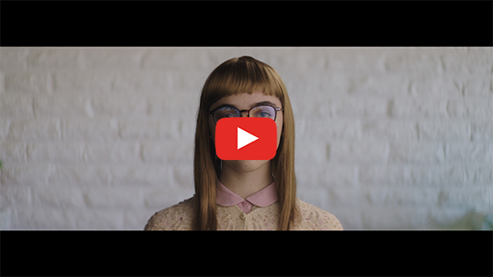
2040 – Future Crystal
Password: 2040_EDU
(https://vimeo.com/showcase/6167669/video/336506398)
Device | Possible Answers
Power of Three | Three different possible versions of VelvetThree different types of home  Indicates various options have been considered before selecting one to continue with. This builds confidence in the narrator.Three compliments from Crystal the Device – reinforced her message and got a reaction from Velvet.
Emotive Language | “Imagine if…” the word ‘imagine’ is very evocative“…donate your excess energy” – a donation is considered generous and socially aware, it makes people feel good about themselves to donate.Device/Crystal “You’re a legend”, “Humans are awesome”, “That choice was good for your soul.”“One day, you’ll be amazed by some the distances our food travelled” – amazed as in surprised, shocked, stunned.
Rhetorical Questions | Velvet: “What were you guys thinking?” This is an accusation that we weren’t thinking logically when making these choices.
Say Again (repetition) | “Imagine if…” – stated twice.“This, Velvet, could be you, or this, or even this.”“And this could be where you live, or here, or even here, but probably not here.”
Undermine opposing views | “In 2016 the US was importing the same amount of beef as it was exporting”.“Fish caught in Norway was flown to China for filleting, then flown back to Norway to be sold”These examples undermine current practices.
Anecdote | “Darling, it’s 7 o’clock, time for family yoga.” Designed to inject humour and make the audience identify with the narrator.
Direct Address | “This Velvet, could be you” – Damon directly addresses his daughter, his intended audience for the film.
Exaggeration | The third potential future Velvet was dressed unusually (perhaps outrageously), followed by the statement, “we love you” meaning no matter how Velvet grew up, there would be no limits to her parent’s love.The second and third potential future homes were exaggerated to provide contrast and humour.
After watching the clip allow students 3-4 minutes to record their responses.
Step 3. Once complete, invite students to work as a class to share their responses and to discuss the use of these devices. Prompt students with the following questions:
- What did you notice?
- What did you like about the clip?
- Which persuasive devices were most effective and why?
- What other persuasive ideas/elements might you have liked to see included in the clip?
- How else would you improve the clip?
Step 4. Invite students to work independently to complete the ‘Think, Pair, Share’ activity on the Student Worksheet. This activity provides an opportunity for them to reflect on the learned content (persuasive devices) as well as any hidden or additional content in the 2040 clips. It will help prepare them for the next task, where they will develop their own futuristic text.
- Column A: Students start by recording their responses to the questions.
- Column B: Once complete, they can find a partner and discuss their ideas, adding any new thoughts to this column.

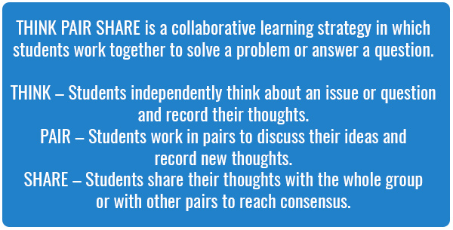
Part C: Your Future Vision
Step 1. Working individually, in pairs or small groups, students will choose ONE persuasive device to focus on. Explain to students that they need to create a futuristic script, short story, comic or storyboard (of about one minute long) that persuades the audience to consider the impact of an environmental issue NOW.
Allow students up to 30 minutes to complete this activity.
Hot tip: The longer the time allowed for a task, the more deliberately and intelligently students will be able to meet the given criteria. However, when students are allowed less time to deliberate on their choices, they are more likely to say YES to radical ideas that come out early in the brainstorming process, leading to higher levels of creativity.
Task elements (information also available on the Student Worksheet):
- Choose ONE persuasive device to focus on.
- Choose an environmental issue that you want to make your audience think about, and persuade them to rethink their behaviour NOW. (Examples: littering, travelling long distances to work every day, unnecessary food packaging, deforestation, use of fossil fuels etc.). Visit the 2040 website (https://www.whatsyour2040.com) to help students find and explore a range of issues that could be used in this activity.
- Consider how this issue might be resolved by the year 2040 and how it would look to a future person learning about how we manage things in the present.
- Choose a character to be the centre of your story.
- Choose a presentation method – script, short story, comic, storyboard.
This task can be planned out in class and completed for homework if there is not enough time to do this in class. Students can share their work upon returning to class.

Step 2. Once complete, invite students to share their final product with one other student/group in the class who will provide feedback using the following structure:
- I really liked… [start with compliments]
- I noticed how you used… [e.g. persuasive device]
- Maybe next time you could… [this enables the audience to share ideas for improvement without getting bogged down in criticism]

Reflection
For this activity, students will put their thumb up if they agree with the statement, thumb down if they disagree and thumb sideways if they are undecided.
Ask the following questions and give students the opportunity to put their thumbs up, down or sideways.
- Put your thumbs up if you learned something new today.
- Put your thumbs up if finding the persuasive devices in the clips was really hard for you.
- Put your thumbs up if finding the devices got easier for you as we moved through the lesson.
- Put your thumbs up if you started to think about what your own future might look like.
- Put your thumbs up if you now know what a persuasive device is.



Differentiated Learning
Extension –
- Student can find examples for more than one persuasive device in the Group Task.
- Students can further practice finding persuasive devices in any of these additional clips: Vision #1 Energy, Vision #2 Agriculture, Vision #3 Seaweed, Vision #4 End Wrap Up, Greenwashing and Misinformation (Password for all: 2040_EDU)
- Students can perform, publish or film and edit their clips.
- Students can write an analysis piece on how the persuasive devices used in the futuristic clips enhance the vision of the clip, for example:
  - Do the persuasive devices used support the audience in imagining a different kind of world?
  - How important are the audio/visual effects in these clips?
  - Do the film techniques add any persuasive elements to the clips?
- Student might choose to research any questions that came up for them during the Think, Pair, Share.
Provisions for Learning Support –
- For the Individual/Paired Task, students can instead find only one or two devices and could even not (or only verbally) provide examples if this is too challenging.
- The Group and Individual/Paired Task (identifying persuasive devices) could be delivered as matching exercises – place the device on one card and the examples on separate cards and have them match them up.
- Teachers could provide semi-filled in table/s for any of the relevant activities.

Take It Further
To expand on student’s learning in this activity, consider following up with this lesson; 2040 Vision For Your Community.

Teacher Reflection
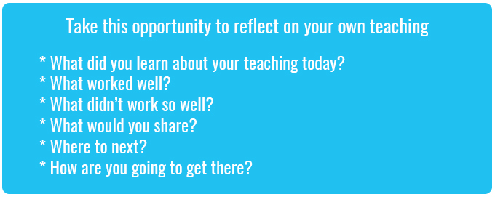

What’s Your 2040?
Record your students’ work in their communities with the hashtag #whatsyour2040 and share their visions in the ‘2040: The Regeneration’ Facebook Group.
The 2040 crew would love to see your class’ work.

