Understanding Persuasion English Years 7 & 8 Student Worksheet
Name: …………………………………. Class: …………..

Thought starter: How might persuasion help us when we share our opinions?

Recapping Persuasion
1. We know that there are always reasons why we want to persuade people. You may want people to believe you, to get them to take action or you may want to change someone’s mind about something.
Here are some very common devices to use when trying to persuade someone:
Persuasive Device | Description
Power of Three | Including lists of three items/reasons in your writing.
Emotive Language | Words, phrases, and imagery that create an emotional response.
Rhetorical Questions | Questions to get your audience thinking – they don’t require an answer.
Say Again (repetition) | Repeating the same word, phrase or idea more than once for emphasis.
Undermine opposing views | Criticise the opposing argument.
Anecdote | Include little stories to illustrate a point.
Direct Address | Involve your audience by speaking to them directly using personal pronouns and shared experience.
Exaggeration | Being over-the-top to get a point across.
2. You are now going to view a clip from a feature-length documentary; 2040. This film is about climate change, and it imagines what the future might look like if we apply currently existing solutions and technologies to help meet the challenges of climate change.
While you watch, pay close attention to what you think the purpose of this film might be; for example, how is the film-maker/narrator (Damon) wanting the audience to respond?
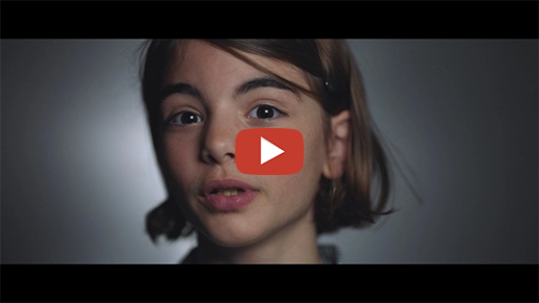
2040 – Setting Up The Journey
Password: 2040_EDU
(https://vimeo.com/showcase/6167669/video/336505203)
Once complete, take a look at the table below. Place a tick (in Column B) next to the listed purpose/s (in Column A) that you think Damon is trying to achieve with his film. It may be one, two or all three of these.
Then, in Column C, note why you think this – what was it in the film that made you think he was doing this?
Column A. Purpose | Column B. Tick | Column C. What Makes You Think This?
To get people to believe him about something
To get someone to take action
To change someone’s mind about something

Analysing Persuasive Devices
1. Group Task
Your teacher is going to divide your class into groups. Each group will be assigned one (or two) of the persuasive devices. Write your group’s device in Column A of the table below.
Watch the first clip again and write down examples of how your selected persuasive device is used in the clip (record in Column B). If you can, give examples (in Column C) of what was said/shown and the intended impact on the audience.
Column A. Persuasive Device | Column B. Example | Column C. Influence
2. Individual/Paired Task
You will now watch another clip from the 2040 documentary. As you watch pay close attention to any persuasive devices that you think are being used (refer to Column A of the table below for a list of persuasive devices):
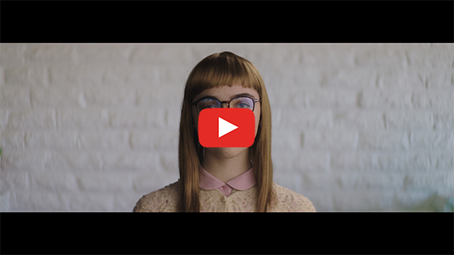
2040 – Future Crystal
Password: 2040_EDU
(https://vimeo.com/showcase/6167669/video/336506398)
Once complete, think about what persuasive devices you saw in the clip and try to give an example of what was said/done to use that device. Record your examples in Column B of the table below:
Column A. Persuasive Device | Column B. Example
Power of Three
Emotive Language
Rhetorical Questions
Say Again (repetition)
Undermine opposing views
Anecdote
Direct Address
Exaggeration
3.Think, Pair, Share
Now think about the two clips from 2040 that you watched and complete the table below:
- Column A: Answer the questions in this column on your own first.
- Column B: Talk about the findings and your thoughts with your partner, then add anything in column B that you hadn’t originally thought of.
 | Column A. | Column B.
What interested or excited you about these clips?
Did you learn anything new about the environment or how persuasive devices are used?
Did the clips provoke any questions or thoughts about your own future? What are they?

Your Future Vision
In small groups, pairs or individually, you will create a futuristic script, short story, comic or storyboard (of about one minute long) that persuades the audience to consider the impact of an environmental issue NOW.
Task elements:
- Choose ONE persuasive device to focus on.
- Choose an environmental issue that you want to make your audience think about, and persuade them to rethink their behaviour NOW. (Examples: littering, travelling long distances to work every day, unnecessary food packaging, deforestation, use of fossil fuels etc.)
- Consider how this issue might be resolved by the year 2040 and how it would look to a future person learning about how we manage things in the present.
- Choose a character to be the centre of your story.
- Choose a presentation method – script, short story, comic, storyboard.
When you share your final product with another student/group, use the following sentence starters to give constructive feedback:
- I really liked… [start with compliments]
- I noticed how you used… [e.g. persuasive device]
- Maybe next time you could… [share ideas for improvement]

